Comprehensive Audit and Analysis for Effective Digital Presence

Description:
- Zoho Corporation, originally founded as AdventNet, Inc. in 1996 by Sridhar Vembu and Tony Thomas in New Jersey, USA, is now headquartered in Chennai, Tamil Nadu, India, with offices in over 80 countries and its US headquarters in Austin, Texas.
- Zoho is an Indian multinational technology company.
- It develops cloud-based software for businesses.
- Popular products include CRM, email services, accounting software, and project management tools.
- Zoho helps companies manage operations digitally.
- Zoho employs over 10,000 people globally.

1️⃣ SEO Analysis

Title tag

Slide Title: SEO Audit – Meta Description
Meta Description Analysis:
- The website uses a well-optimized meta description.
- It clearly explains the purpose of the business.
- It includes important keywords like:
  - software suite
  - businesses
  - applications
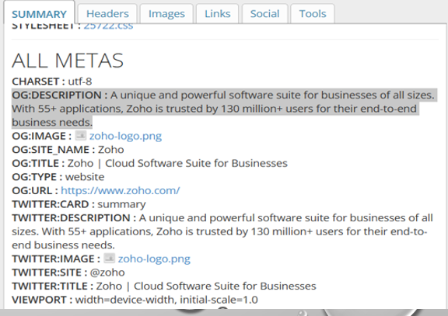
Slide Title: SEO Audit – Keywords
Keyword Analysis:
- The website uses relevant and high-ranking keywords.
- Keywords are related to business software and cloud solutions.
- Primary keywords are well placed in:
  - Meta title
  - Meta description
  - Headings
Examples of Keywords:
- CRM software
- Business applications
- Cloud-based solutions

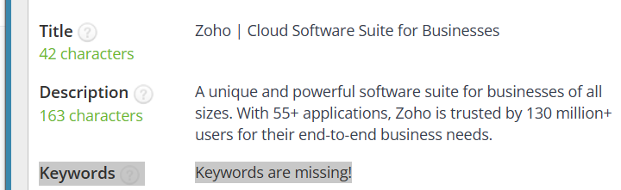
Slide Title: SEO Audit – Heading Structure
Heading Structure Analysis:
- The website uses a proper heading hierarchy.
- Only one H1 tag is used, which is good for SEO.
- Multiple H2 and H3 tags are used to organize content.

Heading structure (H1, H2)
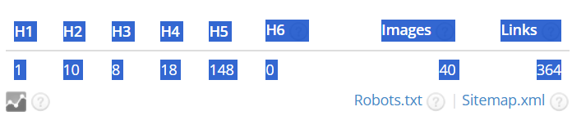
Slide Title: SEO Audit – Image Optimization
Image SEO Analysis:
- The website contains 40 images.
- All images have ALT attributes, which is good for SEO and accessibility.
- However, image TITLE attributes are missing.
- 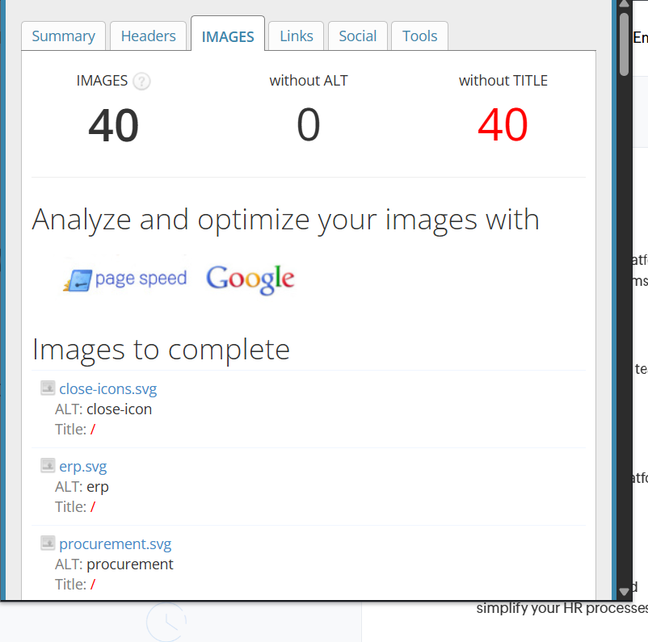
- 2️⃣ Page Speed Test
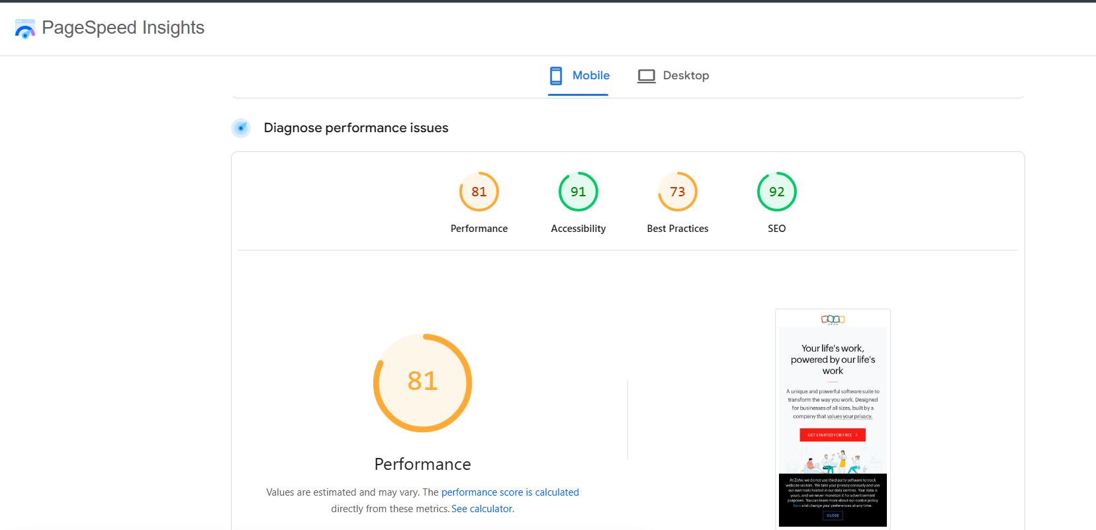
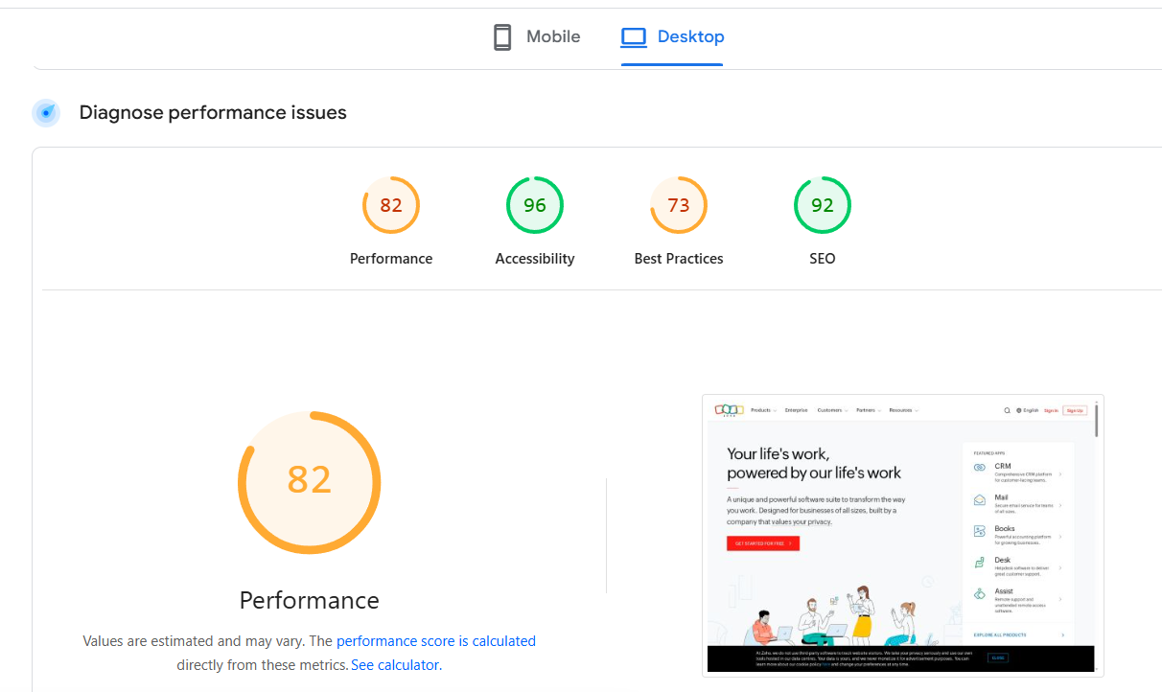
Slide Title: Responsive Design Analysis
Tool Used: Responsive Design Checker
Analysis:
- The website is fully responsive across different screen sizes.
- It adapts well to desktop, tablet, and mobile devices.
- Content, images, and buttons are properly aligned.

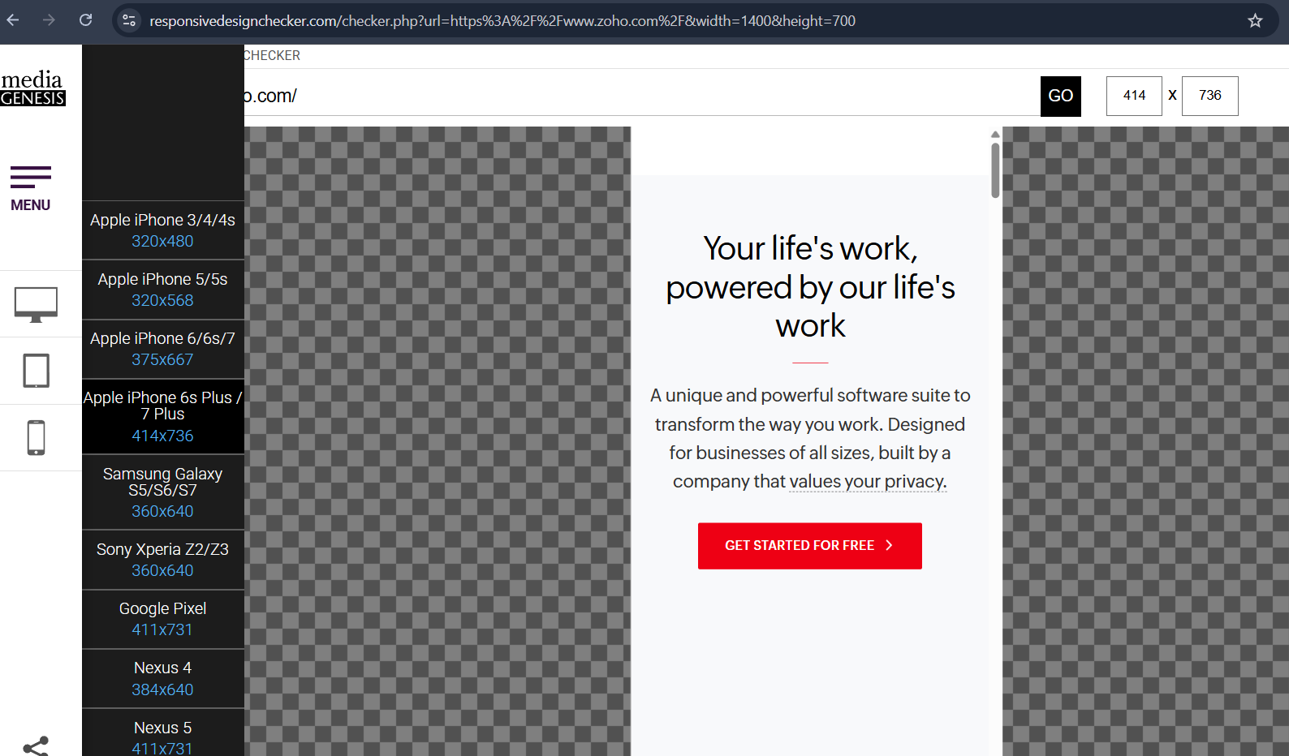

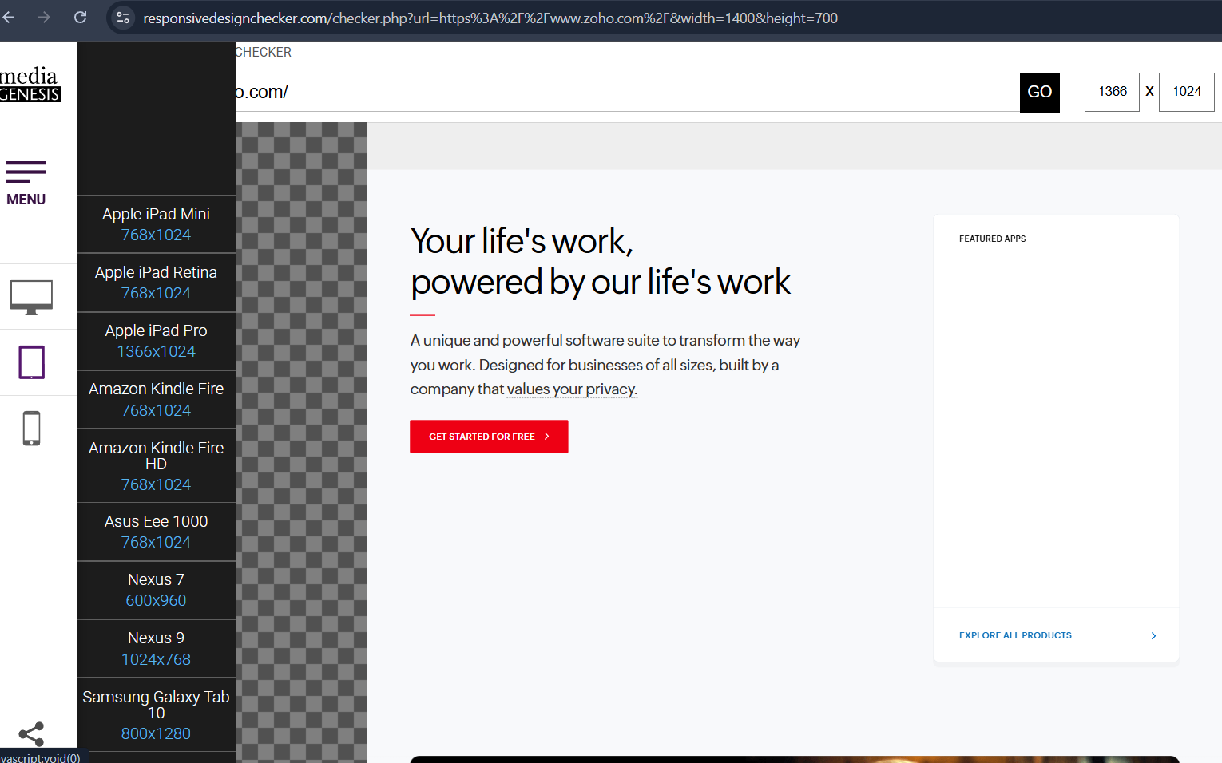

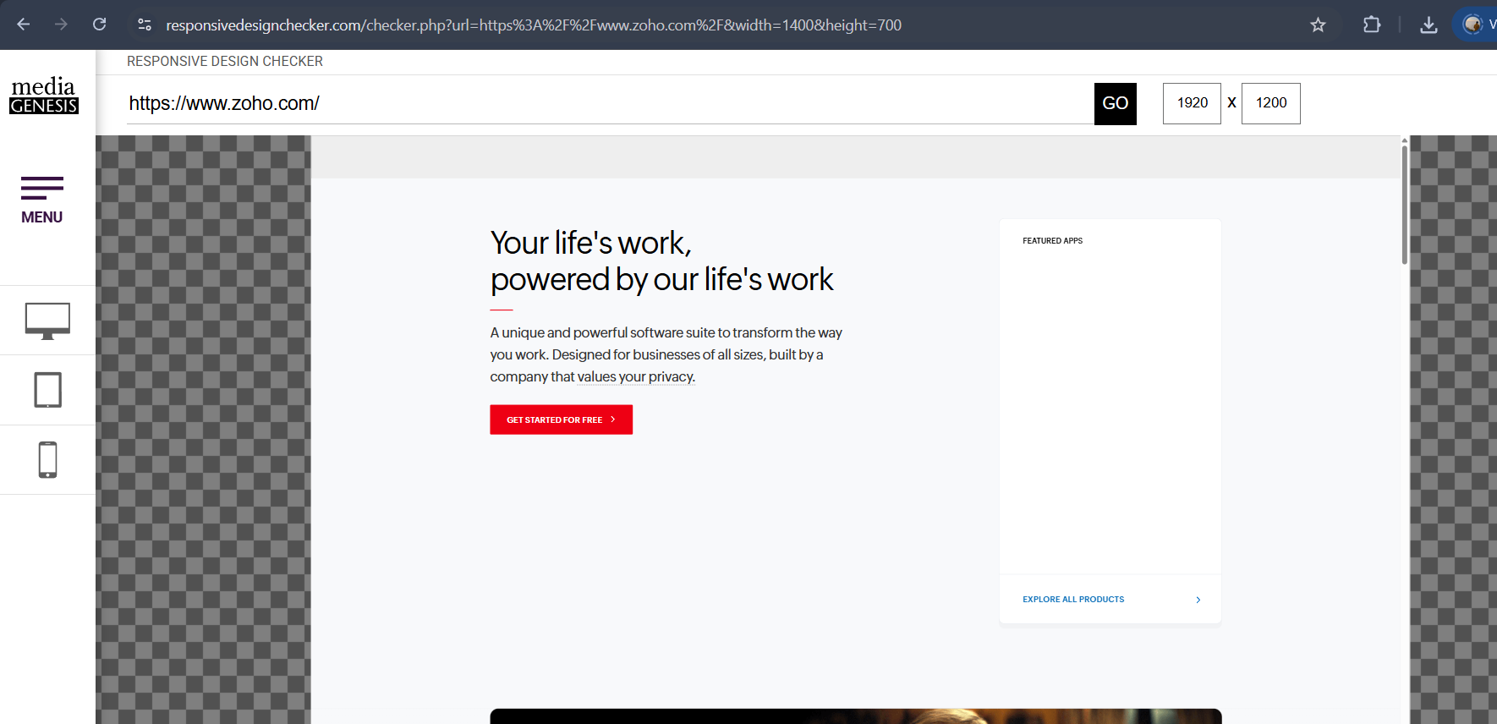

Slide Title: User Experience (UX) Analysis
UX Analysis:
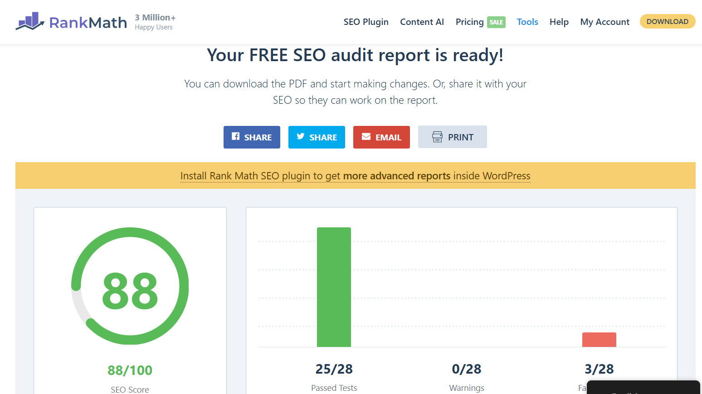

Slide Title: Digital Marketing Strategy
Recommended Strategies:

SEO Strategy
- Improve keyword optimization
- Use long-tail keywords
- Increase internal linking

Content Marketing
- Publish blogs and tutorials
- Create video content
- Add case studies

Social Media Marketing
- Increase engagement on social platforms
- Post regularly
- Use video content

Email Marketing
- Send personalized emails
- Promote offers and free trials
- Share newsletters

https://zohodemo6.wordpress.com/zoho-crm-landing-page/

